Computer Vision-Based Lighting System with Face Angle Detectione

Final year Research and Development project: Wayamba University of Sri Lanka

Supervisor: Mrs Lakmini Wanninayaka

* Artificial lighting accounts for around 1/6 to 1/5 of total generated electricity in the world and it is continuously growing.
* Efficiency of the lighting has improved significantly in the past few decades.
* Incandescent → Florescent lighting → LED
* But the effectiveness of the lighting has come to attention in recent years.
* Vision based lighting control is a highly flexible technique which can be used in a range of applications.

Aim of the project:

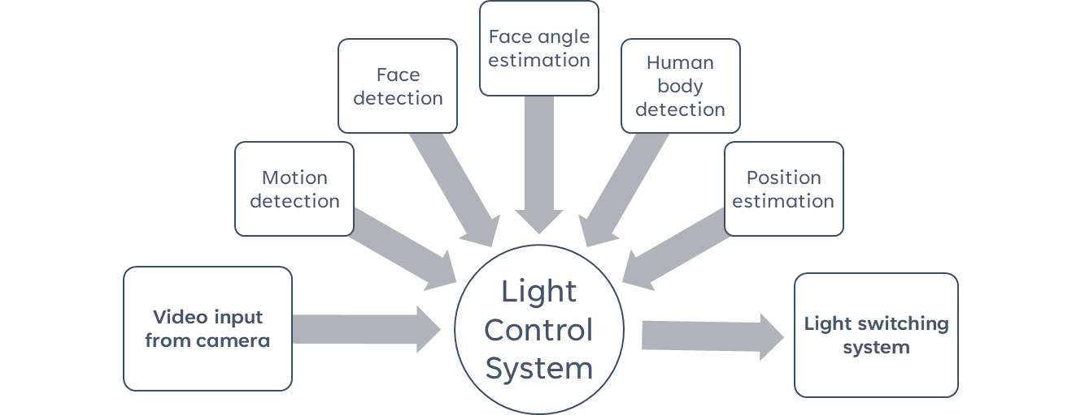To save the electricity by increasing the effectiveness of lighting through an automatic light control system with facing angle and position estimation



Inventory control system for a computer hardware store

This system is developed to enhance the efficiency of a PC hardware shop that uses manual inventory control system.

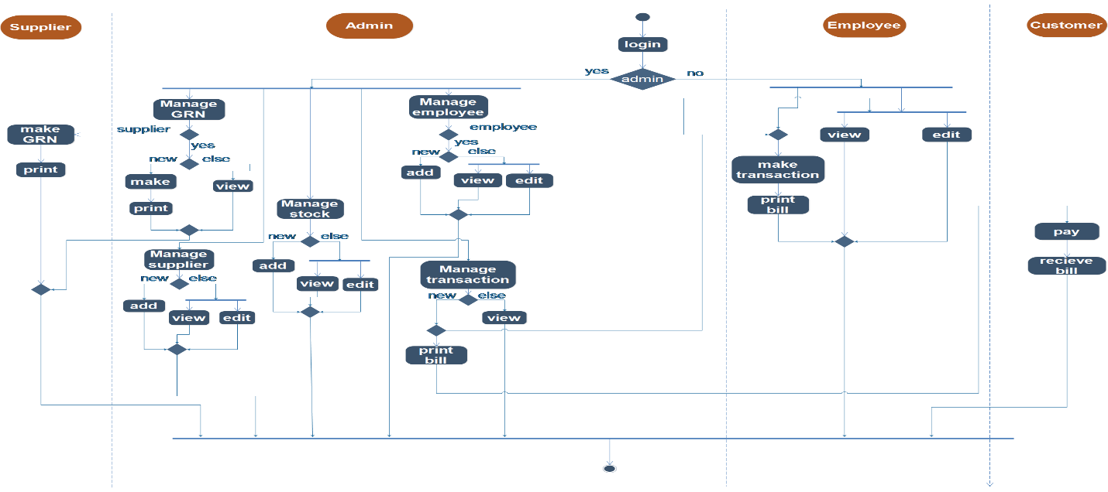Through this system, the shop will be able to manage suppliers, employees, stock and transactions; track warranty details of a hardware and make goods received note

Development of A 2D ENDLESS RUNNER GAME

Tools and Technology

In this game player have to control the movements of the fish. Player should collect foods to gain health. If player goes through the obstacle health will be deduce. If player hits a net or health become zero game will be over. Game became harder with the time

Development of AN ANDROID APP FOR AUTOMOTIVE REPAIR/SERVICE REMINDING AND RECORDING

Tools and technology



Users can maintain different profiles for each vehicle they own. Reminding of events are done based on either time, milage or both.

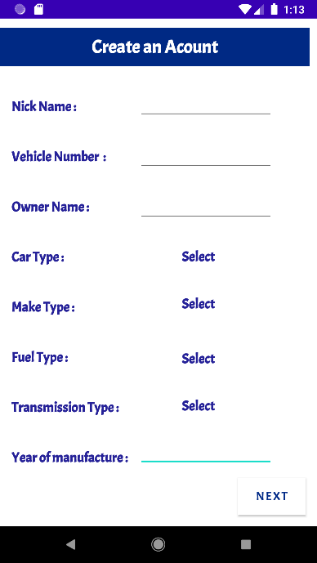

APPARATUS CONTROLLING SYSTEM FOR THE ELECTRONICS LABOROTARY

Aim was to enhance the efficiency of the Electronics laboratory of the faculty of applied sciences, Wayamba University of Sri Lanka, that uses a Manual System.

Developed system handles, item issuing, receiving, tracking items, inventory controlling and report generation.

